7200 Al Moammar Information Systems Co (MIS).
Introduction:
Al Moammar Information systems is a Saudi company established in 1979 to empower local business with IT solutions after that it started growing more and more because the technologies developed and became a must nowadays. MIS now is one of the most reliable and well-known companies in the sector of, software, hardware, and systems in Saudi Arabia. We selected MIS for two main reasons. The first reason is, the demand for systems and software is getting higher every day as we saw in the COVID-19 pandemic, all of us studied or worked remotely. The second reason is the stock price of MIS. Last year the price was in the range of 30s but, now it reached 150s and the shift is significant.
Last year stock price for MIS:
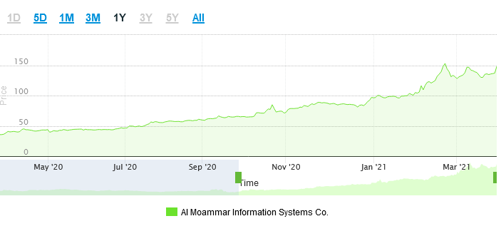
The main reason for the significant price change is because of the demand on the systems from the companies, to make their employees work remotely during COVID-19. But there is a lot of work in Al Moammar Information systems to work in big projects such as establishing a digital bank in Saudi Arabia also, they made a contract in 2020/11/18 with the ministry of health to operate and maintain the digital infrastructure of 72 hospitals in the Eastern and northern region.
References:
(Tadawul, 2021)
(MIS, 2021)

